**Objectives of this practical**

* To retrieve all & selective records via the SELECT query.
* To sort the result of a query
* To filter the result of a query via the WHERE clause

Practical 5 – SELECT and WHERE Clause

Contents

Background 2

Restoring the database 3

BrightSpace Submission 6

MCQ Section 7

Section A: Select & Sort records 7

Section B: SELECT with WHERE Clause 9

With AND Operator 9

With OR Operator, IN Operator, LIKE operator, iLIKE Operator 10

Parentheses within Parentheses 11

# Background

You have been tasked to provide some key information on the staff. The information you compile will address the following questions and provide some insights on the profile of the staff.

# Restoring the database

Before you start the practical, you will practice restoring a database from a backup file. Download the backup file named “*practical4_final_state.sql*” on BrightSpace->Practical->Practical 5.

It is **important** that you can restore from the backup file on your laptop. You will be required to perform a similar restore process for the **MST**.

1. Remove the database:

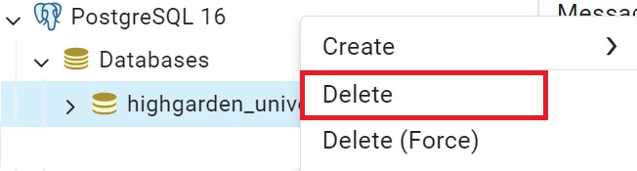

Click Yes to confirm.

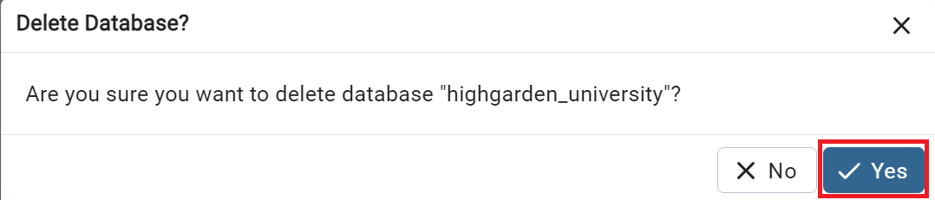

1. Re-create the database:

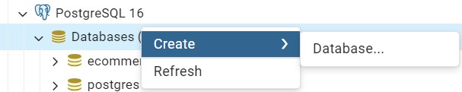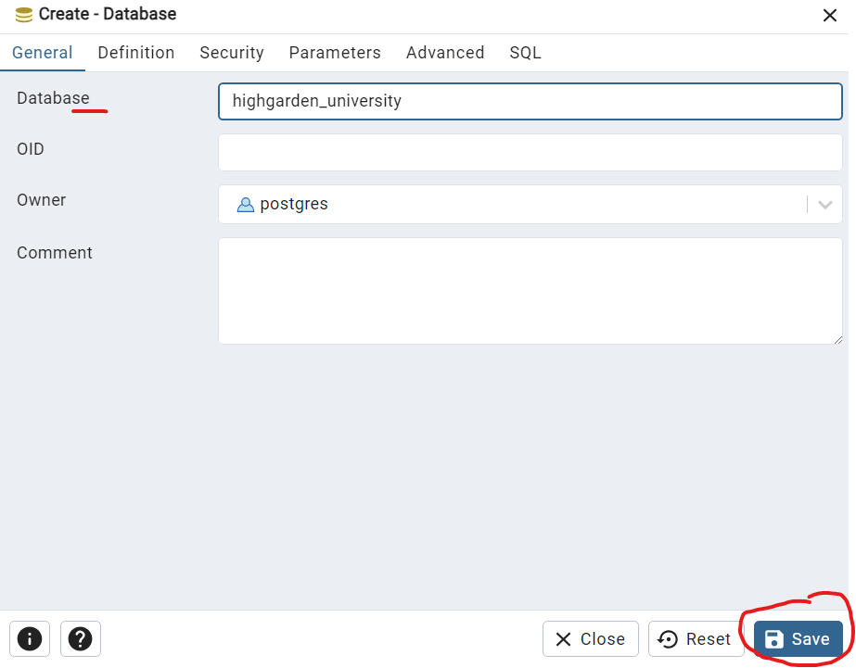

Choose Restore

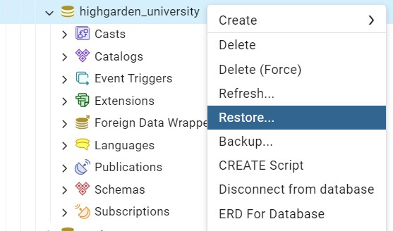

Under the General Tab, browse and select the file you want to restore from

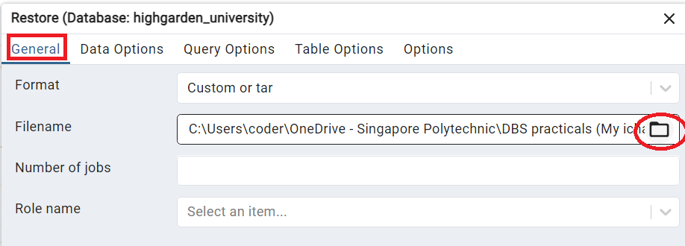

Under the Data Options Tab, in the “Do not save” section, toggle the Owner option and Privileges option.

Then click Restore.

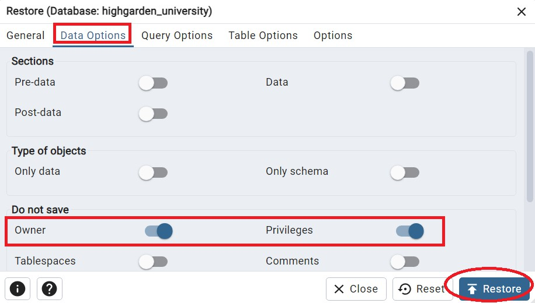

You will see the “Process started” message.

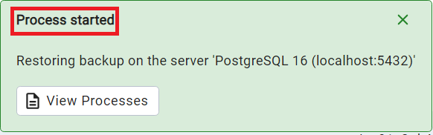

If the restore process is successful, you will see the “Process completed” message.

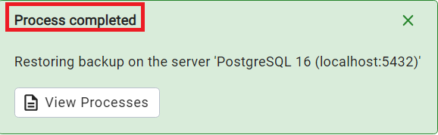

1. Error Code – 3221225781

You may encounter an error code (3221225781) when trying to restore database from the backup file.

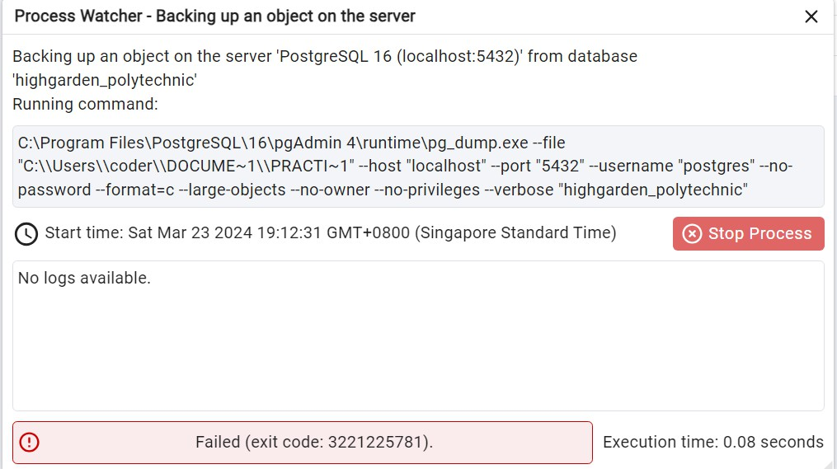

You will need to amend the configuration under **Files > Preferences > Path > Binary Paths.**

Try to restore the database again after the amendment.

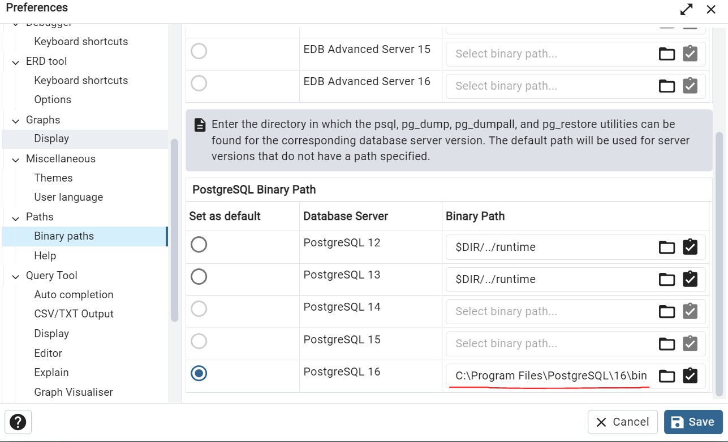

# BrightSpace Submission

You are required to **submit** your answers for the **MCQ Section** & **all parts of Section A Question 1.**

* + **Download** the practical_5_submission.zip from BrightSpace.
  + **Unzip** the zip file. There will be a root folder with the necessary files.
  + Fill the answers to the MCQs using the **mcq.xlsx file**.
  + Fill the sql query to each question using the provided **.sql files**. (Only one answer for each file)
    - You can open the .sql file directly in PgAdmin using the Query Tool

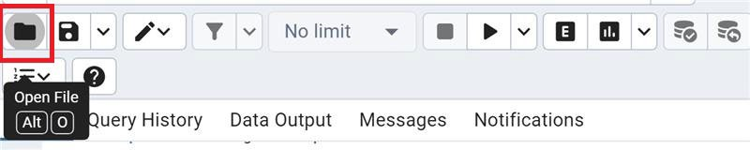

* + - Alternatively, you can open the .sql file with visual studio, paste your answer from the Query Tool and save the .sql file
  + Upon completion, zip up the **root folder**. (Do not zip at any higher-level folder)

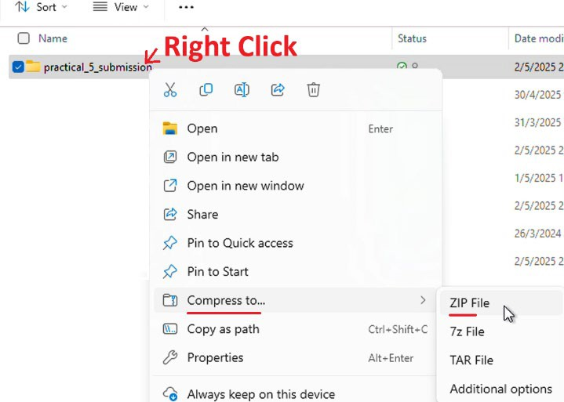

* + Submit the zip file on BrightSpace using the submission link.

# MCQ Section

1. Which SQL clause is used to filter records?
   1. SELECT
   2. WHERE
   3. ORDER BY
   4. GROUP BY
2. Which clause is used to sort the result set?
   1. WHERE
   2. GROUP BY
   3. ORDER BY
   4. HAVING
3. What does the following SQL do?

SELECT * FROM users WHERE age > 25 AND city = 'New York';

* 1. Selects all users younger than 25 in New York
  2. Selects users from any city with age > 25
  3. Selects users older than 25 who live in New York
  4. Selects all users regardless of age and city

# Section A: Select & Sort records

1.

1. The staff comes from a diverse background.

What are the different citizenships of the staff?

Expected result

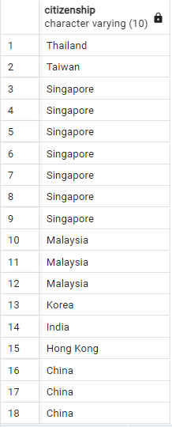*Z to A*

1. Remove repeated values from the above list, if any. [Hint: DISTINCT]
2. What are the birth dates of every staff?

Re-label the headers accordingly to "Name of Staff" and "Date of Birth".

List them as shown below, from the oldest to youngest staff

Expected result

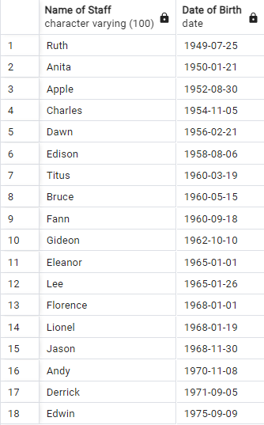

1. The staff directory listing requires staff names for every department.

List the department code and staff name of all staff.

First, sort the result in descending order of department code. For staff working in the same department, display the results in descending order of staff name.

Expected result

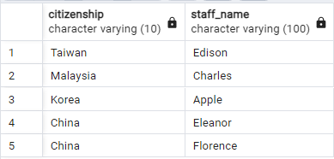

*Z to A*

*A to Z*

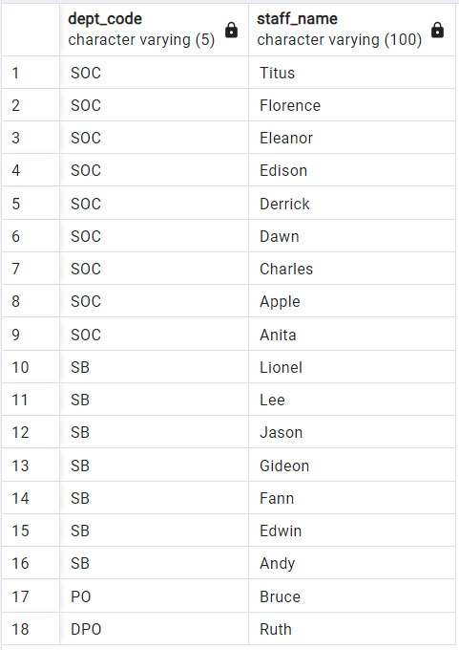

*Z to A*

*Z to A*

# Section B: SELECT with WHERE Clause

Human Resource (HR) would like to reach out to specific groups of staff for various reasons such as communication, provide training, administer benefits etc. Retrieve the required information to support their work.

With AND Operator

2.

a) There are some non-Singaporean staff working at the university.

What citizenships do the foreign staff from School of Computing hold and who are they?

[Note the sequence of staff name for each citizenship.] Expected Result

b) There are also a few male Singaporean staff born in the sixties (from 1960 to 1969 inclusive) working at the university.



Who are they?

[Hint: consider the use of EXTRACT function from the date of birth column]

[https://www.postgresql.org/docs/current/functions-datetime.html#FUNCTIONS-](https://www.postgresql.org/docs/current/functions-datetime.html#FUNCTIONS-DATETIME-EXTRACT) [DATETIME-EXTRACT](https://www.postgresql.org/docs/current/functions-datetime.html#FUNCTIONS-DATETIME-EXTRACT)

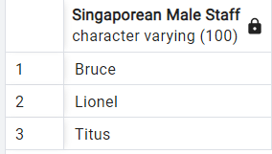Expected Result

With OR Operator, IN Operator, LIKE operator, iLIKE Operator

3.

a)

Who are the staff that hold citizenships from Hong Kong, Korea, Malaysia and Thailand?

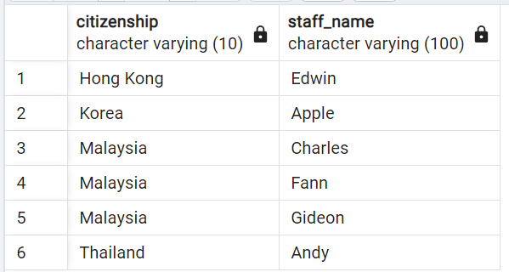[Consider the IN operator] Expected Result

b) List the staff whose highest qualification is a bachelor’s degree or whose designation contain the word ‘deputy’. The abbreviation for bachelor’s degree starts with the uppercase alphabet ‘B’.

List the staff [Sort the result in ascending order of staff name within ascending order of highest qualification.]

Hint: Consider the iLIKE operator. It is similar to the LIKE operator, LIKE operator is case sensitive while iLIKE operator is case **in**sensitive.

Expected Result

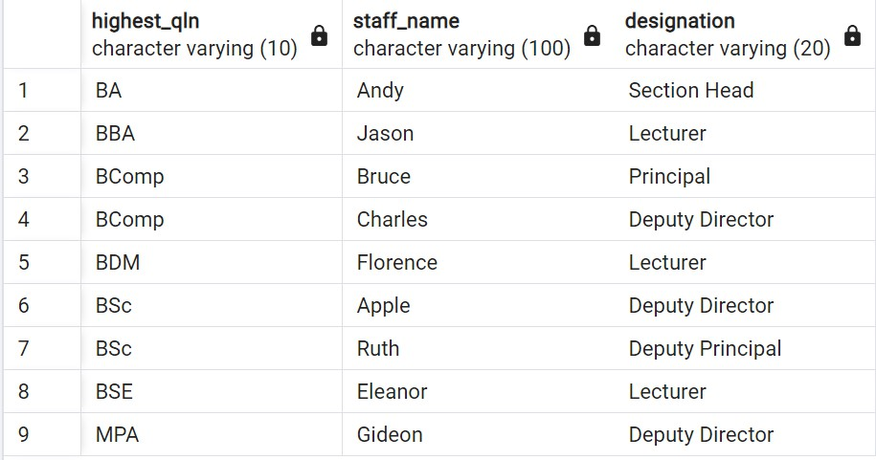

Parentheses within Parentheses

4.

a)

Find the female staff who are paid between 4000 and 7000 or the male staff who are paid between 2000 and 6000. Sort in ascending order of pay within ascending order of gender.

Expected Result

